April 23, 2020 UPDATED RE: VIRTUAL MOVING SALE

Thank you SO very much for joining in on the Virtual Moving Sale. It’s a rather weird time to be packing up.
The items shown below are still available.

Additionally, Saturday, April 25th, I will place several miscellaneous items on my patio and hanging on my garden fence that are free to any who would find them of use.

Sofa
$75 34d x 76w x 31h
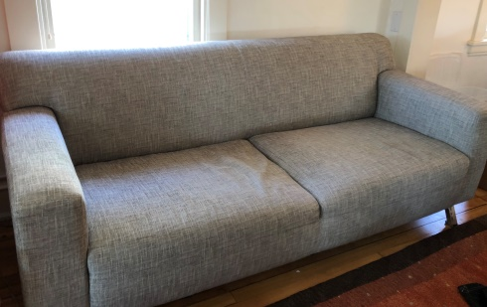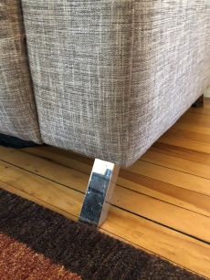

Old Farmer’s cupboard
$20 30w x 13 ½ d x 34h (backboard). Holes drilled, used for TV.
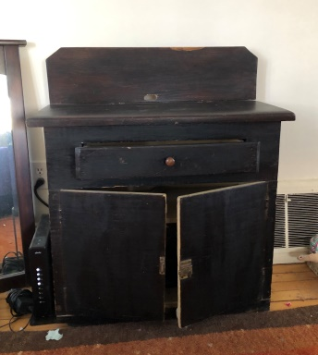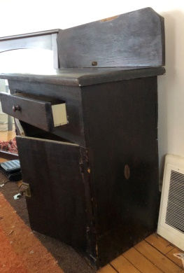

Antique Oak mirror
$25 Vertical or horizontal use…or as table top. 42 ½ x 24 ½. Couple of scratches on glass.
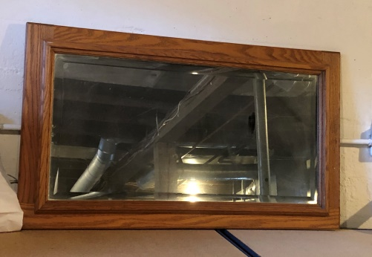

Antique Chinese cupboard with gold butterflies
$500 OR BEST OFFER 21d x 52w x 68h Valued between $1200 and $1200
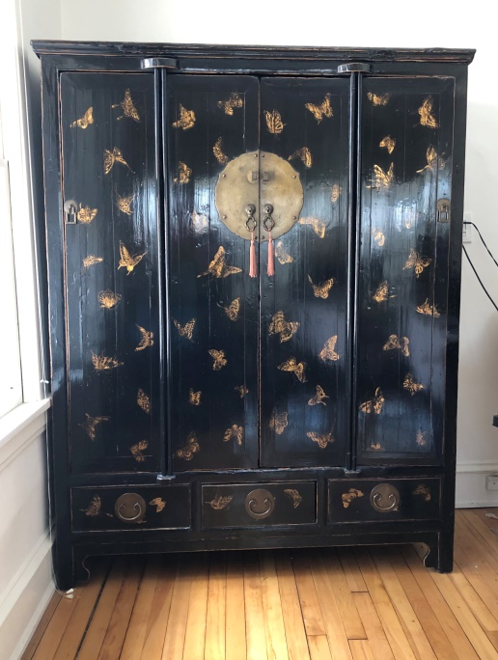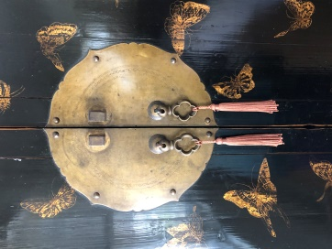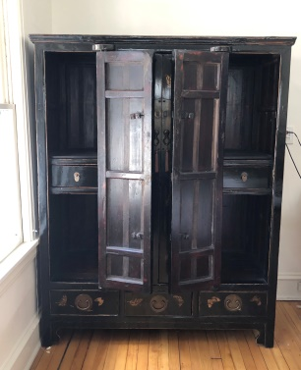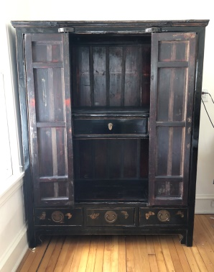

Pair of small Frontgate exterior fake trees
$10 Lights no longer work
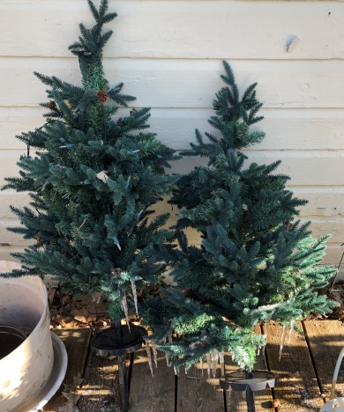

Overhead projector
$25
